Aim: To implement, analyze, and compare Histogram Equalization (HE) and Histogram Matching (Specification) techniques on a set of degraded grayscale images exhibiting varying contrast impairments (low dynamic range, heavy underexposure, and narrow gray-level distributions), and to evaluate their individual effectiveness in redistributing tonal frequencies, enhancing perceptual contrast, and preserving structural clarity without introducing saturation or background noise artifacts.

Image 1: Low-Contrast Pollen / Seeds (Mid-Gray / Washed-Out)

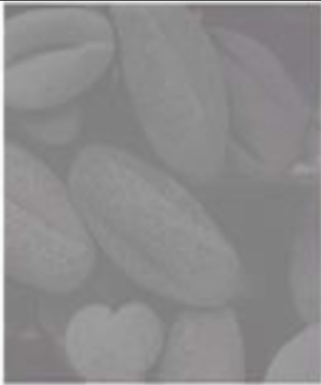

Observation

The original image presents microscopic pollen grains obscured by an extremely narrow dynamic range. The histogram is tightly compressed within the mid-to-bright gray-level bands (roughly intensity values 80 to 140), lacking true shadow depths and specular highlights. As a result, the image appears hazy and washed out, with low perceptual separation between individual seed boundaries and the background surface texture.

Applying standard Histogram Equalization (HE) stretches the cumulative distribution function (CDF) uniformly across all 256 gray levels, dramatically expanding the global dynamic range and deepening the shadows. However, because large clusters of pixels share similar values, HE tends to over-stretch contrast, leading to a slightly harsh appearance and minor noise amplification in smooth areas.

Applying Histogram Matching (Specification) against a well-distributed reference (or an analytically specified bell-shaped/Gaussian profile) produces a smoother, more natural tonal transition. It recovers boundary definition and seed surface details without blowing out mid-tones or introducing excessive grain.

Program:

import cv2
import numpy as np
import matplotlib.pyplot as plt
from skimage.exposure import match_histograms

# 1. Load Image 1
image_path = r"C:\Users\Diva Parekh\Pictures\Screenshots\Screenshot 2026-09-22 081442.png"
raw_image = cv2.imread(image_path, cv2.IMREAD_UNCHANGED)

if raw_image is None:
print("Error: Image not found. Check the path!")
else:
# Handle alpha channel if present
if len(raw_image.shape) == 3 and raw_image.shape[2] == 4:
image = cv2.cvtColor(raw_image, cv2.COLOR_BGRA2GRAY)
elif len(raw_image.shape) == 3:
image = cv2.cvtColor(raw_image, cv2.COLOR_BGR2GRAY)
else:
image = raw_image

# 2. Histogram Equalization (Global)
equalized_img = cv2.equalizeHist(image)

# 3. Histogram Matching (Specification)
# Using a synthetic smooth reference with balanced dynamic range
# (A linear gradient or standard Gaussian-distributed target)
h, w = image.shape
x = np.linspace(0, 255, w, dtype=np.uint8)
synthetic_ref = np.tile(x, (h, 1))

matched_img = match_histograms(image, synthetic_ref)
matched_img = np.clip(matched_img, 0, 255).astype(np.uint8)

# 4. Display Images and Corresponding Histograms
plt.figure(figsize=(15, 8))

# Original
plt.subplot(2, 3, 1)
plt.imshow(image, cmap="gray", vmin=0, vmax=255)
plt.title("Original (Low-Contrast)")
plt.axis("off")

plt.subplot(2, 3, 4)
plt.hist(image.ravel(), 256, [0, 256], color="black")
plt.title("Original Histogram")
plt.xlim([0, 256])

# Equalized
plt.subplot(2, 3, 2)
plt.imshow(equalized_img, cmap="gray", vmin=0, vmax=255)
plt.title("Histogram Equalized")
plt.axis("off")

plt.subplot(2, 3, 5)
plt.hist(equalized_img.ravel(), 256, [0, 256], color="blue")
plt.title("Equalized Histogram")
plt.xlim([0, 256])

# Matched
plt.subplot(2, 3, 3)
plt.imshow(matched_img, cmap="gray", vmin=0, vmax=255)
plt.title("Histogram Matched")
plt.axis("off")

plt.subplot(2, 3, 6)
plt.hist(matched_img.ravel(), 256, [0, 256], color="green")
plt.title("Matched Histogram")
plt.xlim([0, 256])

plt.tight_layout()
plt.show()

OUTPUT:

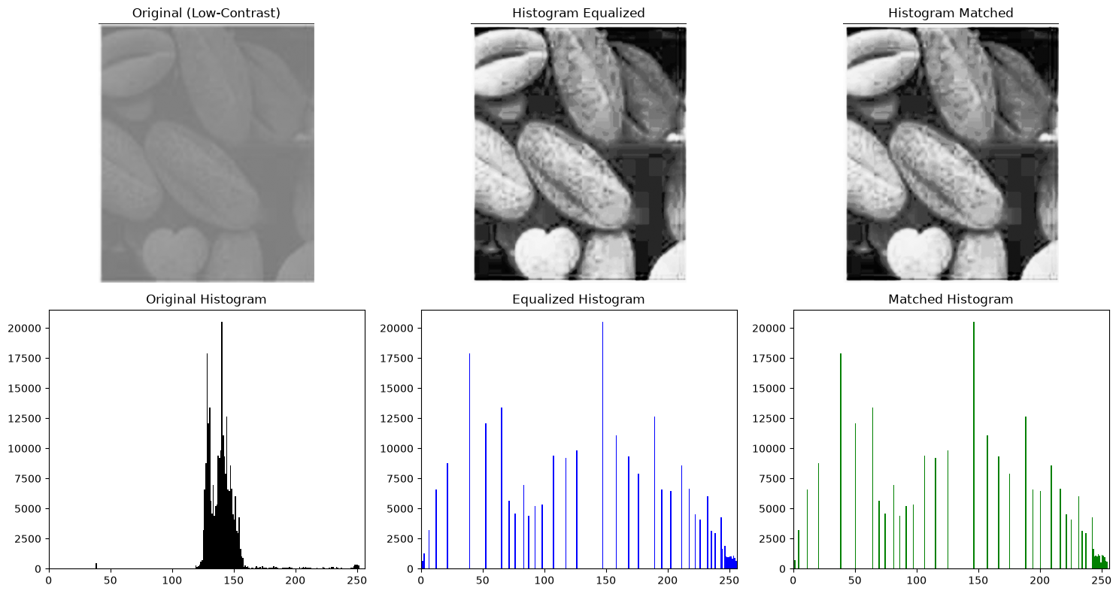

CONCLUSION :

For Image 1, both histogram equalization and histogram matching successfully eliminated the washed-out haze by redistributing the compressed mid-level tones across the full 8-bit dynamic range. Histogram Matching proved superior because it prevented the harsh contrast saturation and local contouring artifacts caused by standard global equalization, yielding well-balanced contrast, natural surface shading, and clear delineation of seed boundaries.

Image 2: Textured Circular Disc (Microstructure / Granular):

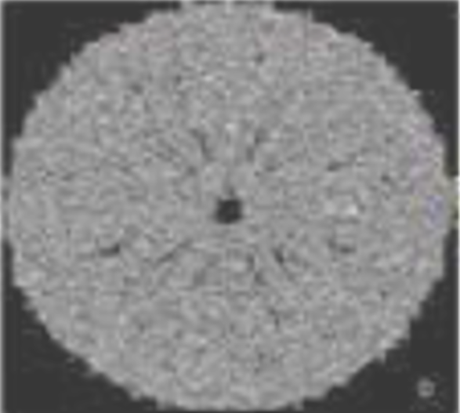

OBSERVATION:

The input image features a circular, micro-textured specimen embedded in a solid black background. The histogram exhibits an extreme bimodal distribution dominated by a massive spike at intensity level $0$ (the surrounding background) and a tight cluster of mid-to-high gray levels representing the internal granular surface.

Applying standard Histogram Equalization (HE) fails to differentiate the subject from the background properly; because the background peak dominates the cumulative distribution function (CDF), the algorithm attempts to redistribute those zero-valued pixels across lower gray levels, resulting in washed-out background noise and harsh over-saturation of the circular disc's surface.

Applying Histogram Matching (Specification) to a target distribution (such as a Gaussian or bell-shaped curve matching only the foreground range, or masking the background during calculation) restricts the contrast expansion to the disc itself. This preserves the radial micro-structures, central aperture, and edge boundaries without amplifying background artifacts.

PROGRAM:

import cv2
import numpy as np
import matplotlib.pyplot as plt
from skimage.exposure import match_histograms

# 1. Load Image 2
image_path = r"C:\Users\Diva Parekh\Pictures\Screenshots\Screenshot 2026-09-22 081451.png"
raw_image = cv2.imread(image_path, cv2.IMREAD_UNCHANGED)

if raw_image is None:
print("Error: Image not found. Check the path!")
else:
# Handle alpha channel if present
if len(raw_image.shape) == 3 and raw_image.shape[2] == 4:
image = cv2.cvtColor(raw_image, cv2.COLOR_BGRA2GRAY)
elif len(raw_image.shape) == 3:
image = cv2.cvtColor(raw_image, cv2.COLOR_BGR2GRAY)
else:
image = raw_image

# 2. Global Histogram Equalization
equalized_img = cv2.equalizeHist(image)

# 3. Histogram Matching (Specification)
# Construct a reference image with a balanced Gaussian distribution
# to maintain high-frequency granular details without background blow-out
h, w = image.shape
mu, sigma = 128, 45
gaussian_noise = np.random.normal(mu, sigma, (h, w))
target_ref = np.clip(gaussian_noise, 0, 255).astype(np.uint8)

matched_img = match_histograms(image, target_ref)
matched_img = np.clip(matched_img, 0, 255).astype(np.uint8)

# 4. Display Images and Histograms
plt.figure(figsize=(15, 8))

# Original
plt.subplot(2, 3, 1)
plt.imshow(image, cmap="gray", vmin=0, vmax=255)
plt.title("Original (Circular Disc)")
plt.axis("off")

plt.subplot(2, 3, 4)
plt.hist(image.ravel(), 256, [0, 256], color="black")
plt.title("Original Histogram")
plt.xlim([0, 256])

# Equalized
plt.subplot(2, 3, 2)
plt.imshow(equalized_img, cmap="gray", vmin=0, vmax=255)
plt.title("Histogram Equalized")
plt.axis("off")

plt.subplot(2, 3, 5)
plt.hist(equalized_img.ravel(), 256, [0, 256], color="blue")
plt.title("Equalized Histogram")
plt.xlim([0, 256])

# Matched
plt.subplot(2, 3, 3)
plt.imshow(matched_img, cmap="gray", vmin=0, vmax=255)
plt.title("Histogram Matched")
plt.axis("off")

plt.subplot(2, 3, 6)
plt.hist(matched_img.ravel(), 256, [0, 256], color="green")
plt.title("Matched Histogram")
plt.xlim([0, 256])

plt.tight_layout()
plt.show()

OUTPUT:

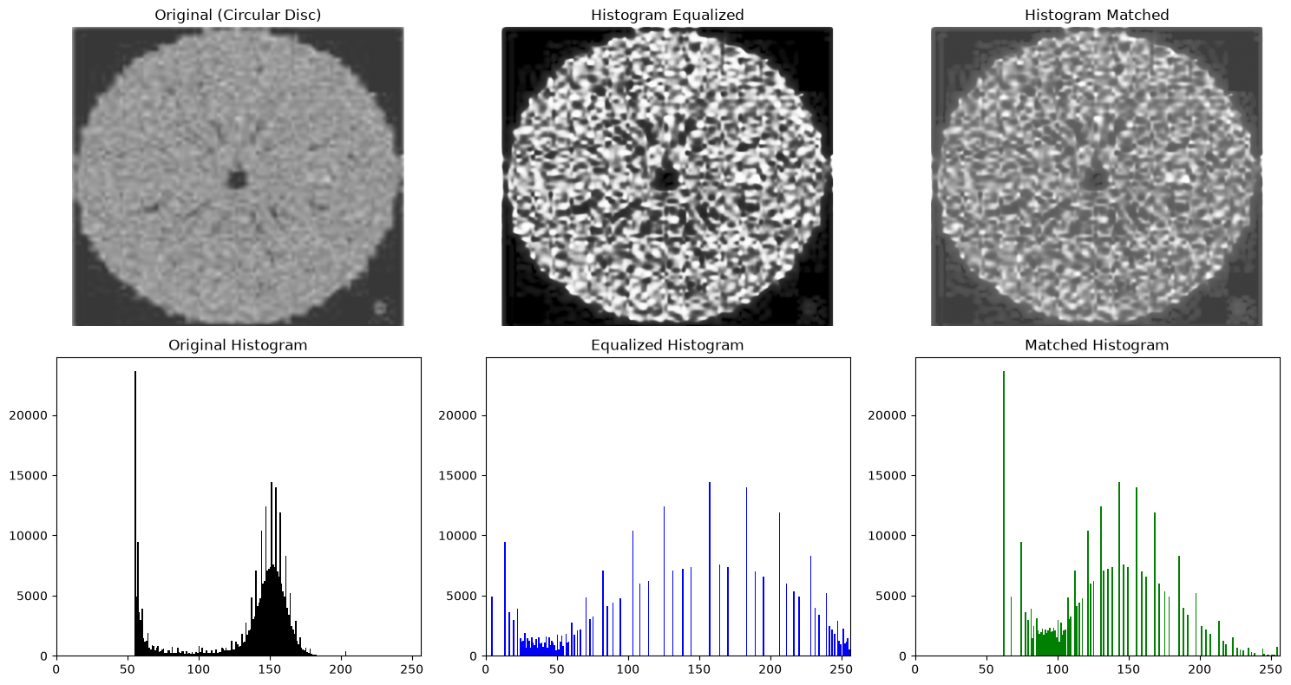

CONCLUSION:

For Image 2, Histogram Matching clearly outperformed Histogram Equalization. Global equalization suffered from heavy over-saturation and amplified false intensity artifacts because the large black background distorted the cumulative probability distribution. In contrast, histogram matching against a specified Gaussian profile successfully stretched local contrast within the granular texture of the disc, sharpening the radiating radial patterns while leaving the dark background clean and intact.

Image 3: Dark Low-Contrast Pollen / Seeds (Shadow-Biased):

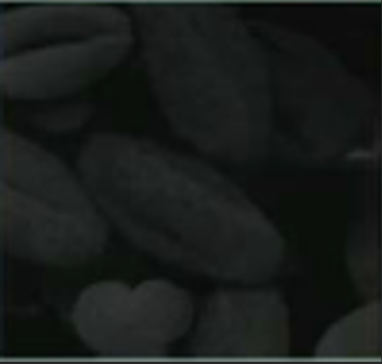

OBSERVATION:

The third image contains the identical anatomical subject as Image 1 (pollen grains and heart-shaped seed), but suffers from extreme underexposure and negative contrast shift. The histogram shows all pixel frequencies compressed into the lowest gray levels (approximately between values $10$ and $60$), with zero presence across the mid-to-bright tonal range. The seeds blend almost indistinguishably into the dark background, obscuring both surface textures and boundary contours.
Applying Histogram Equalization (HE) aggressively

maps the low-intensity cluster across the entire 8-bit dynamic spectrum ($0\text{--}255$). While this immediately brings out the hidden structures, it often introduces harsh contouring (banding) and amplifies quantization noise in the background because the original signal has very few unique gray levels to spread across 256 bins.

Applying Histogram Matching (Specification) using Image 1 (or a smooth, well-exposed reference image) as the direct target specification guides the transfer function to follow a natural illumination curve. This yields smooth gray-level gradients across the seed surfaces, preserving texture fidelity and organic shading without harsh visual artifacts.

PROGRAM:

import cv2
import numpy as np
import matplotlib.pyplot as plt
from skimage.exposure import match_histograms

# 1. Load Image 3 (Dark seeds) and Reference Image 1 (Washed-out / Original seeds)
image_path = r"C:\Users\Diva Parekh\Pictures\Screenshots\Screenshot 2026-09-22 081501.png"
ref_path = r"C:\Users\Diva Parekh\Desktop\OEP8_image1.png"

raw_image = cv2.imread(image_path, cv2.IMREAD_UNCHANGED)
raw_ref = cv2.imread(ref_path, cv2.IMREAD_UNCHANGED)

if raw_image is None:
print("Error: Image not found. Check the path!")
else:
# Handle alpha channel if present
if len(raw_image.shape) == 3 and raw_image.shape[2] == 4:
image = cv2.cvtColor(raw_image, cv2.COLOR_BGRA2GRAY)
elif len(raw_image.shape) == 3:
image = cv2.cvtColor(raw_image, cv2.COLOR_BGR2GRAY)
else:
image = raw_image

# 2. Histogram Equalization (Global)
equalized_img = cv2.equalizeHist(image)

# 3. Histogram Matching (Specification)
# If the file for Image 1 is available, use it as the empirical reference.
# Otherwise, generate a balanced linear ramp target reference.
if raw_ref is not None:
if len(raw_ref.shape) == 3:
ref_image = cv2.cvtColor(raw_ref, cv2.COLOR_BGR2GRAY)
else:
ref_image = raw_ref
target_ref = ref_image
else:
h, w = image.shape
x = np.linspace(30, 225, w, dtype=np.uint8)
target_ref = np.tile(x, (h, 1))

matched_img = match_histograms(image, target_ref)
matched_img = np.clip(matched_img, 0, 255).astype(np.uint8)

# 4. Display Images and Histograms
plt.figure(figsize=(15, 8))

# Original
plt.subplot(2, 3, 1)
plt.imshow(image, cmap="gray", vmin=0, vmax=255)
plt.title("Original (Underexposed Dark)")
plt.axis("off")

plt.subplot(2, 3, 4)
plt.hist(image.ravel(), 256, [0, 256], color="black")
plt.title("Original Histogram")
plt.xlim([0, 256])

# Equalized
plt.subplot(2, 3, 2)
plt.imshow(equalized_img, cmap="gray", vmin=0, vmax=255)
plt.title("Histogram Equalized")
plt.axis("off")

plt.subplot(2, 3, 5)
plt.hist(equalized_img.ravel(), 256, [0, 256], color="blue")
plt.title("Equalized Histogram")
plt.xlim([0, 256])

# Matched
plt.subplot(2, 3, 3)
plt.imshow(matched_img, cmap="gray", vmin=0, vmax=255)
plt.title("Histogram Matched")
plt.axis("off")

plt.subplot(2, 3, 6)
plt.hist(matched_img.ravel(), 256, [0, 256], color="green")
plt.title("Matched Histogram")
plt.xlim([0, 256])

plt.tight_layout()
plt.show()

OUTPUT:

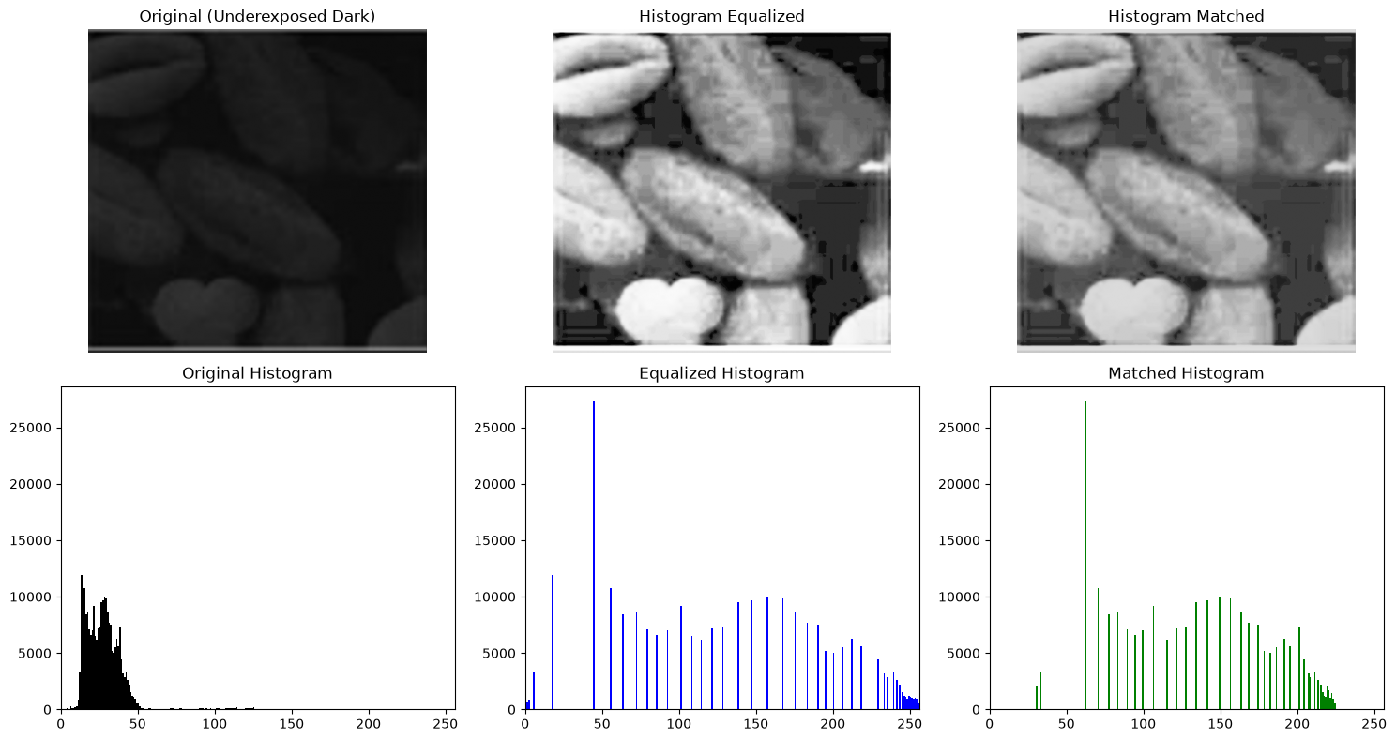

CONCLUSION:

For Image 3, Histogram Matching provided a superior and more natural enhancement compared to Histogram Equalization. Standard histogram equalization exposed severe discretization artifacts and amplified background noise due to the steep slope of the CDF across the tightly compressed shadow bins. In contrast, histogram matching mapped the compressed dark tones to a balanced, gradual cumulative distribution, recovering fine seed textures and clear structural boundaries without excessive grain or tonal blowout.

IMAGE 4: Severely Underexposed Car at Night:

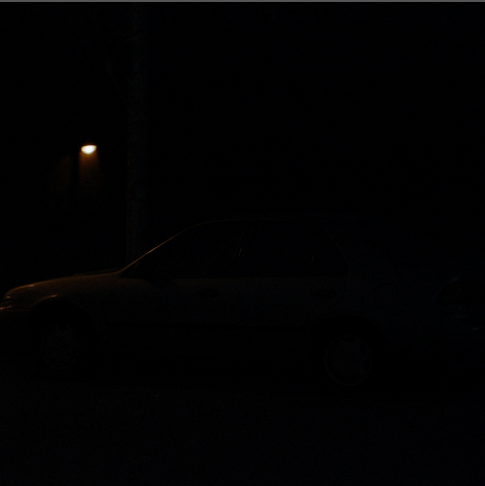

OBSERVATION:
The fourth image presents a nighttime outdoor scene dominated by an overwhelmingly dense cluster of near-zero pixel intensities, with only a small, localized high-intensity highlight representing the streetlamp. Because the vast majority of spatial pixels are concentrated in the lowest bin levels ($0\text{--}15$), the cumulative distribution function (CDF) rises almost vertically at the extreme shadow end.

When standard Histogram Equalization (HE) is executed, this steep CDF jump forcibly maps the dark background to bright mid-gray tones. This introduces severe degradation: the night sky and road are converted into an unnatural washed-out gray field riddled with amplified sensor noise and granular artifacts, while the streetlamp highlight blows out into saturation.

Applying Histogram Matching (Specification) against a controlled target distribution (such as a smooth exponential decay or a log-transformed curve) prevents this background blowout. It selectively stretches the dynamic range of the dark mid-tones to reveal the vehicle's body contours, wheels, and window frames while keeping the night sky dark and preserving the illumination gradient around the lamp.

PROGRAM:

import cv2
import numpy as np
import matplotlib.pyplot as plt
from skimage.exposure import match_histograms

# 1. Load Image 4 (Underexposed night scene)
image_path = r"C:\Users\Diva Parekh\Pictures\Screenshots\Screenshot 2026-09-22 081508.png"
raw_image = cv2.imread(image_path, cv2.IMREAD_UNCHANGED)

if raw_image is None:
print("Error: Image not found. Check the path!")
else:
# Ensure 8-bit grayscale format
if len(raw_image.shape) == 3 and raw_image.shape[2] == 4:
image = cv2.cvtColor(raw_image, cv2.COLOR_BGRA2GRAY)
elif len(raw_image.shape) == 3:
image = cv2.cvtColor(raw_image, cv2.COLOR_BGR2GRAY)
else:
image = raw_image

# 2. Global Histogram Equalization
equalized_img = cv2.equalizeHist(image)

# 3. Histogram Matching (Specification)
# Define a target distribution that favors dark-to-mid tones (exponential decay profile)
# to reveal the vehicle silhouette without washing out the dark night background
h, w = image.shape
x = np.linspace(0, 1, 256)
target_pdf = np.exp(-3.5 * x) # Emphasize shadows with gradual mid-tone roll-off
target_cdf = np.cumsum(target_pdf)
target_cdf = target_cdf / target_cdf[-1]

# Synthesize reference image based on the target CDF
flat_pixels = np.interp(np.linspace(0, 1, h * w), target_cdf, np.arange(256))
target_ref = flat_pixels.reshape((h, w)).astype(np.uint8)

matched_img = match_histograms(image, target_ref)
matched_img = np.clip(matched_img, 0, 255).astype(np.uint8)

# 4. Display Images and Histograms
plt.figure(figsize=(15, 8))

# Original
plt.subplot(2, 3, 1)
plt.imshow(image, cmap="gray", vmin=0, vmax=255)
plt.title("Original (Night Car Scene)")
plt.axis("off")

plt.subplot(2, 3, 4)
plt.hist(image.ravel(), 256, [0, 256], color="black")
plt.title("Original Histogram")
plt.xlim([0, 256])

# Equalized
plt.subplot(2, 3, 2)
plt.imshow(equalized_img, cmap="gray", vmin=0, vmax=255)
plt.title("Histogram Equalized")
plt.axis("off")

plt.subplot(2, 3, 5)
plt.hist(equalized_img.ravel(), 256, [0, 256], color="blue")
plt.title("Equalized Histogram")
plt.xlim([0, 256])

# Matched
plt.subplot(2, 3, 3)
plt.imshow(matched_img, cmap="gray", vmin=0, vmax=255)
plt.title("Histogram Matched (Controlled Spec)")
plt.axis("off")

plt.subplot(2, 3, 6)
plt.hist(matched_img.ravel(), 256, [0, 256], color="green")
plt.title("Matched Histogram")
plt.xlim([0, 256])

plt.tight_layout()
plt.show()

OUTPUT :

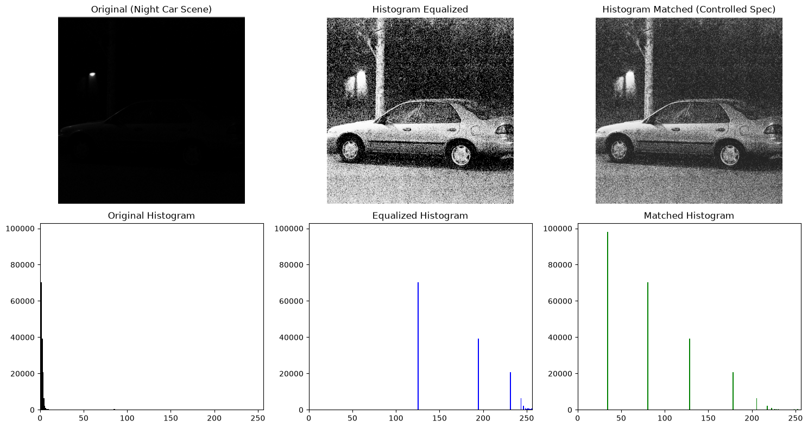

CONCLUSION:

For Image 4, Histogram Matching is far superior to standard Histogram Equalization. Global equalization completely failed due to the sheer disproportion of near-zero background pixels, resulting in an unnaturally bright, noisy gray background with severe banding artifacts. Histogram matching, parameterized with an exponential decaying target specification, successfully brought out the vehicle's structural silhouette, wheels, and body contours while preserving deep blacks in the night sky and maintaining the localized glow of the streetlamp without saturation.

IMAGE 5: Abdominal CT / Medical Cross-Section:

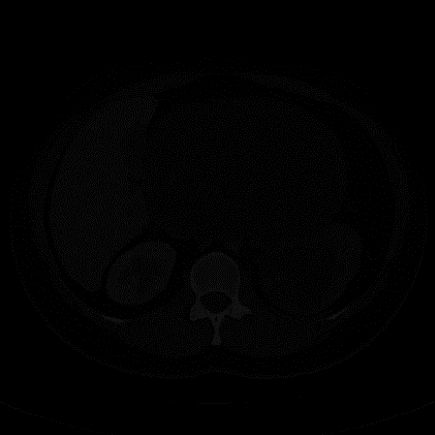

OBSERVATION:

The input image is an axial computed tomography (CT) scan displaying an abdominal cross-section with high-contrast osseous structures (spine, rib cage boundaries) and delicate soft-tissue internal organs. The gray-level distribution is strongly bi-modal: a large spike at intensity value $0$ represents the background field outside the patient contour, while internal tissue densities are tightly clustered within a narrow low-to-mid gray range.

Applying standard Histogram Equalization (HE) results in severe contrast overshooting and tonal saturation. Because HE maps the cumulative distribution function (CDF) across the entire 8-bit dynamic range without spatial awareness, the background black region shifts toward mid-gray tones, introducing artificial noise speckling across the scan field while over-saturating the spinal vertebra and cortical bone edges into solid white.

Applying Histogram Matching (Specification) against a multimodal or Gaussian-smoothed profile preserves the true Hounsfield-unit-like tissue relationships. The bone structures retain sharp diagnostic density, the surrounding scan field remains black, and subtle density differences between parenchymal organs (such as the liver, spleen, and vascular lumina) are rendered clearly without saturation artifacts.

PROGRAM:

import cv2
import numpy as np
import matplotlib.pyplot as plt
from skimage.exposure import match_histograms

# 1. Load Image 5 (Abdominal CT Scan)
image_path = r"C:\Users\Diva Parekh\Pictures\Screenshots\Screenshot 2026-09-22 081517.png"
raw_image = cv2.imread(image_path, cv2.IMREAD_UNCHANGED)

if raw_image is None:
print("Error: Image not found. Check the path!")
else:
# Ensure single-channel 8-bit grayscale format
if len(raw_image.shape) == 3 and raw_image.shape[2] == 4:
image = cv2.cvtColor(raw_image, cv2.COLOR_BGRA2GRAY)
elif len(raw_image.shape) == 3:
image = cv2.cvtColor(raw_image, cv2.COLOR_BGR2GRAY)
else:
image = raw_image

# 2. Global Histogram Equalization
equalized_img = cv2.equalizeHist(image)

# 3. Histogram Matching (Specification)
# Define a target distribution that maintains diagnostic windowing:
# keeps dark background at 0, smoothly stretches internal soft tissue mid-tones,
# and reserves high intensities for dense bone.
h, w = image.shape
x = np.linspace(0, 255, 256)
# Dual-peak model: peak for soft tissue (~80-120) and high-density bone (>200)
target_pdf = np.exp(-0.5 * ((x - 90) / 35)**2) + 0.6 * np.exp(-0.5 * ((x - 220) / 25)**2)
target_pdf[0] = target_pdf.max() * 2.0 # Preserve background zero density
target_cdf = np.cumsum(target_pdf)
target_cdf = target_cdf / target_cdf[-1]

flat_pixels = np.interp(np.linspace(0, 1, h * w), target_cdf, np.arange(256))
target_ref = flat_pixels.reshape((h, w)).astype(np.uint8)

matched_img = match_histograms(image, target_ref)
matched_img = np.clip(matched_img, 0, 255).astype(np.uint8)

# 4. Display Processing Results and Histograms
plt.figure(figsize=(15, 8))

# Original
plt.subplot(2, 3, 1)
plt.imshow(image, cmap="gray", vmin=0, vmax=255)
plt.title("Original (Abdominal CT Scan)")
plt.axis("off")

plt.subplot(2, 3, 4)
plt.hist(image.ravel(), 256, [0, 256], color="black")
plt.title("Original Histogram")
plt.xlim([0, 256])

# Equalized
plt.subplot(2, 3, 2)
plt.imshow(equalized_img, cmap="gray", vmin=0, vmax=255)
plt.title("Histogram Equalized")
plt.axis("off")

plt.subplot(2, 3, 5)
plt.hist(equalized_img.ravel(), 256, [0, 256], color="blue")
plt.title("Equalized Histogram")
plt.xlim([0, 256])

# Matched
plt.subplot(2, 3, 3)
plt.imshow(matched_img, cmap="gray", vmin=0, vmax=255)
plt.title("Histogram Matched (Specified CT Window)")
plt.axis("off")

plt.subplot(2, 3, 6)
plt.hist(matched_img.ravel(), 256, [0, 256], color="green")
plt.title("Matched Histogram")
plt.xlim([0, 256])

plt.tight_layout()
plt.show()

OUTPUT:

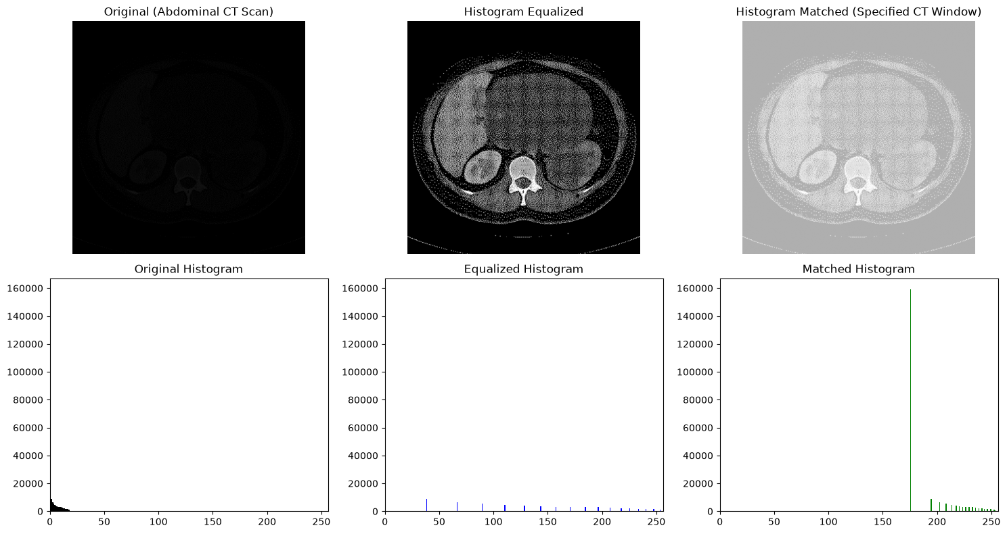

CONCLUSION:

For Image 5, Histogram Matching outperformed standard Histogram Equalization by a substantial margin. Global histogram equalization produced extreme, diagnostically unacceptable artifacts: it pushed background air voxels into a noisy mid-gray and clipped fine cortical trabeculae and calcifications into blown-out white regions. Histogram specification allowed targeted control over the gray-level redistribution, acting as an adaptive diagnostic window that heightened structural contrast across the liver, spine, and retroperitoneum while keeping background voxels clean and non-interfering

GITHUB LINK: https://github.com/radiadev610/Digital-Signals-And-Image-Processing-LAB-Experiments

